Registration of Doctorate Thesis on the ProQuest Dissertations & Theses Global
University Library, The University of Tokyo

ProQuest Dissertations & Theses Global is one of the largest dissertation/theses database provided by ProQuest. It indexes dissertations and Master’s theses from around the world, especially North American graduate schools and European universities.
The University of Tokyo has agreed with ProQuest to provide the full text and the bibliographic information (such as title, author, etc.) of doctorate theses which are available online through the UTokyo Repository, based on the permissions of the author and co-authors. We request that doctorate theses that are to be published in full text in the repository also be made available in this database. (Except in cases where permission cannot be obtained from co-authors, publishers, etc.)
Notes
- If a part of your thesis is published in a journal of a commercial publisher, you may not be allowed to publish it on this database. Please check the publisher's condition before deciding whether or not to allow your thesis to be published on this database.
- If the title of the paper is in Japanese, please add an English translation in parentheses to the “Title of thesis” section of the “Letter of Authorization”.
- If there are co-authors, please confirm that the co-authors’ consents have been obtained on the “Letter of Consent and Acceptance”.
About ProQuest Dissertations & Theses Global
- An international database of multi-disciplinary dissertations and theses, which is used by more than 3,000 academic institutions and 4 million researchers worldwide.
- More than 6.5 million citations and 3 million full-text works.
- The thesis data provided by UTokyo to this database will have additional reciprocal links to ProQuest bibliographic databases such as “Web of Science”.
URL: https://search.proquest.com/pqdtglobal (*Available only to contracting institution members)
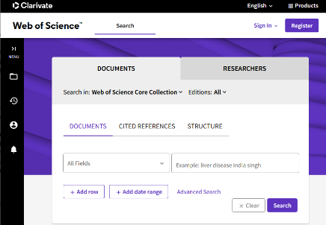
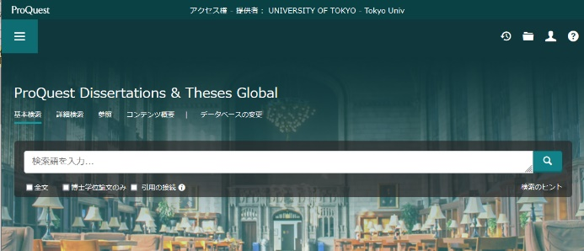
Provides bibliographic and full-text data of theses for which permissions have been granted.
Cross-linking
Increased availability for users worldwide
Web of Science, etc.
Publication in ProQuest Dissertations & Theses Global
Publication in The UTokyo Repository
(Published on the Internet)
*Provides bibliographic and full-text data of dissertations to the National Diet Library.

Repository Publication (Internet Publication) Permission
Thesis Data
ProQuest Dissertations & Theses Global Permission
Degree recipient

